Hands-On Exercises

Input and Output

**Setup Instructions:**

1. Create a new Java Project called “FullStackDay8”.
2. Create your classes in the package “io”
3. Define your classes as given below for each assignment.

Assignment 01

Write a program to count the number of times a character appears

in a File.

[Note : The character check is case insensitive... i.e, 'a' and

'A' are considered to be the same]. You can use Input.txt  as the input file.

Sample Input and Output:

Enter the file name

Input.txt

Enter the character to be counted

r

File 'Input.txt' has 99 instances of letter 'r'.

Assignment 02

Write a Java program to read a file’s content line by line.

You can use test.txt as the input file.

Assignment 03

Write a program to copy contents from one file to another and

check the output.You can use Input.txt  as the input file.

Sample Input and Output:

Enter the input file name

Input.txt

Enter the output file name

Output03.txt

File is copied.

Assignment 04

Write a program to count the occurrences of each word in an input

file and write the word along with its corresponding count in an

output file.

[Note: The words should be sorted alphabetically in the output

file]

(Hint : Consider using Map Collection)

For Example, let's assume the following are the contents of

inputFile.txt

Manoj works at Team Lease

Katari works at Team Lease

Sureka works at Team Lease

Harish works at Team Lease

Anitha works at Team Lease

Janani works at Team Lease

D:\>Java FileWordCount inputFile.txt outputFile.txt

After Execution of the program the contents of outputFile.txt

should be as below

Anitha : 1

Harish : 1

Janani : 1

Katari : 1

Manoj : 1

Sureka : 1

Team Lease : 6

at : 6

works : 6

Assignment 05

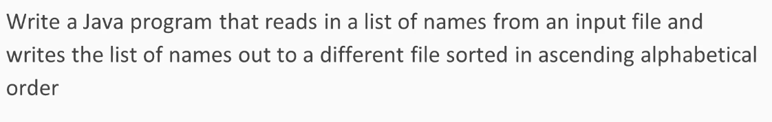

Assignment 06

Create the following class to demonstrate a program to append an item to an existing file using RandomAccessFile class.

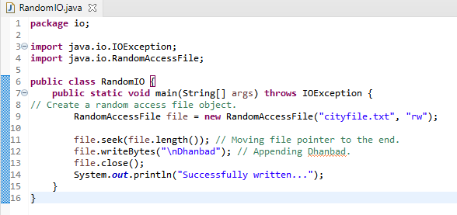

Output:

On refeshing the project, you should see your file in the root.



***cityfile.txt contents before execution:***

Sydney  
New York  
Mumbai

***cityfile.txt contents after execution:***

Sydney  
New York  
Mumbai  
Dhanbad

Assignment 06

Let’s take another example program based on the above methods of random access file for practice.

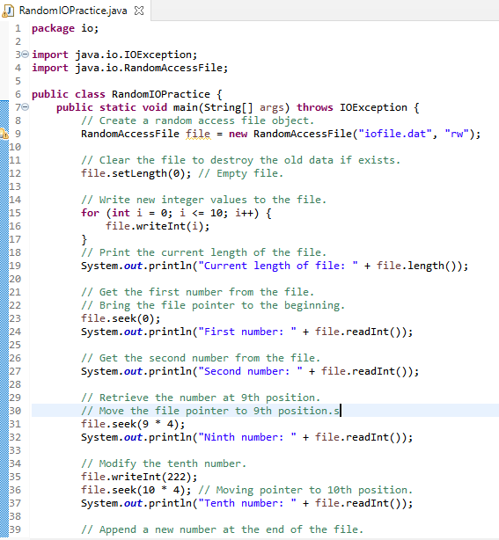

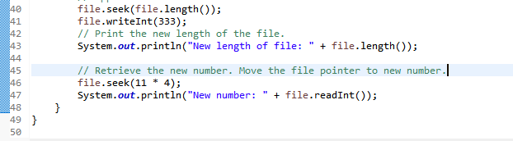

Output:

On refeshing the project, you should see your file in the root.

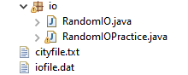

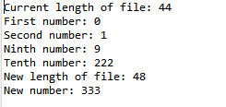

****Explanation:****

a) A RandomAccessFile creates a file named infile.dat with mode rw to allow both read and write operations.

b) file.setLength(0) sets the length to 0 to clear file. It destroys the old data of the file.

c) The for loop writes 11 int values from 0 to 10 into the file. Since each int value takes 4 bytes, the total length of the file returned from file.length() is now 44 as shown in the output.

d) Calling file.seek(0) sets the file pointer to the beginning of the file. file.readInt() reads the first value and moves the file pointer to the next number. The second number is read as 1.

e) file.seek(9 * 4) moves the file pointer to the ninth number. file.readInt() reads the ninth number and moves the file pointer to the tenth number.

f) file.write(222) writes a new tenth number at the current position. The previous tenth number is completely destroyed.

g) file.seek(file.length()) moves the file pointer to the end of the file.

h) file.writeInt(333) writes a 333 to the file. Now the length of the file is increased by 4. So, file.length() returns 48.

i) file.seek(11 * 4) moves the file pointer to the eleventh number. The new eleventh number, 333, is displayed as shown in the above output.

Assignment 07

Create the following program for writing to the console using Console class.

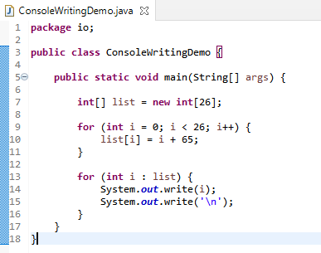

Run the file from the cmd prompt as demonstrated in the training sessions.

Output:





*****************************************************************************************************************